EYE INJURIES IN DOGS – WHAT YOU SHOULD KNOW!
From PETPLACE.COM
By Dr. Jon
Dog's eyes are amazing.
Many people ask questions about what dogs can see. Today I thought I'd talk about a few questions that clients ask about canine eyesight (and one they don't but should). Just a warning - there is a photo below of one type of injury; I've included it to help readers learn how ulcerations look.
1. Do dogs see in color?
Answer: Dogs do see in color, but their perception of color is not the same as it is for people. They cannot distinguish between red, orange, yellow or green. They can see various shades of blue and can differentiate between closely related shades of gray that are not distinguishable to people.
2. How do dogs see compared to us?
Answer: When comparing dog and human vision, people are better at depth perception, color perception and seeing small details of an object. Dogs are better at seeing in dim light, responding to an image rapidly, and detecting the slightest motion. They also have better peripheral vision.
3. Do dogs get eye problems?
You bet. Dogs can get many eye disease including glaucoma, inflammation in the eye, and corneal ulcers. Eye injuries are common - many of which can be prevented. They are commonly caused by dogs getting shampoo in their eyes during bathing. Frequently either the shampoo irritates sensitive eye tissue or they rubs their eyes and create an ulcer. The most frequently damaged portion of the eye is the cornea, This transparent structure covers the outside of the eye and protects its sensitive contents. At only a half-millimeter to a millimeter thick, it doesn't take much to injure this crucial part of your dog's anatomy.
Exposure to foreign materials such as dust or wood chips can further damage eyes. In particular, household spray cleaners must be used with caution and NEVER while a pet is in the room. We frequently see ulcers in the eyes of dogs who were scratched by another pet or ran into something in the yard. Shampoo and cleaners are by far the biggest culprits.
Here is a photo of a dog with a superficial corneal ulcer. The ulcerated area appears green due to a fluorescein stain used in veterinary practice to determine the size and depth of the damage.
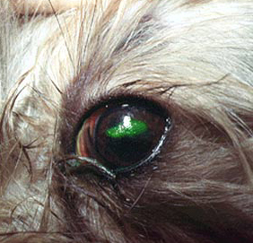
Signs of an eye injury include squinting, rubbing at the eye, or redness in the surrounding tissues. Some dogs might experience watery eyes. If you see any of these signs, please call your vet. Another thing you can do is to prevent your dog from rubbing at his eye until you get him to medical help.
Care of an injured eye must begin as quickly as possible to prevent further damage. That frequently means a trip to the emergency vet...and lots of bills to follow. Pl

